21st Sunday
in Ordinary Time

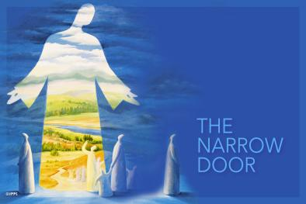
AUGUST 21, 2022
THIS WEEKEND’S READINGS
First: Isaiah 66:18-21
Second: Hebrews 12:5-7, 11-13
Gospel: Luke 13:22-30
FOCUS: We strive to be faithful always.
The liturgy today gives us a chance to step back and think of our journey as disciples. This journey is not a short sprint, but a marathon. Its urgency is always there. The narrow gate is always there. But we are
not alone, and we have food for the journey. Our Eucharistic celebration strengthens us and gives us
the grace to continue our journey to be faithful.

LITURGY OF THE WORD:
In the first reading, Isaiah shares the Lord’s promise of gathering all nations before him. The author of the Letter to the Hebrews exhorts them to strengthen themselves and endure their challenges as “discipline.” In the Gospel, Jesus is asked if only a few people will be saved. He tells them to strive to enter the kingdom of God through the narrow gate.

MASS INTENTIONS
5 p.m.: Barbara Venditti, Margaret Boyle
and the Ryan, Borst & Costello families
10 a.m.: Frances Hernandez, Carlos Sanabria
and Domingo Rodriguez

TREASURER’S REPORT
August 7-14: Totaled $ 5,049.48
Envelopes: $ 2,022.00 – Online: $ 3,027.48
THANK YOU

.
MEETING/NOMINATION REMINDERS
Our Parish Meeting, in conjunction with a Coffee Social, will take place after the 10 a.m. Mass on Sunday, September 11. This will be an opportunity for you to give feedback on the Sunday Mass schedule. However, no decision will be made until after the Ministry Fair the weekend of October 15-16.
In order to return to two Masses on Sunday, there would need to be an increase in volunteers, including archangels, greeters, choir members and lectors. At the Ministry Fair, parishioners will be able to speak
with members of the various ministries to ascertain which might be a good fit.
Also on September 11, Parish Council nomination forms will be available in the church vestibules for the three seats that will be vacated in January of 2023.
The Parish Council, which meets on the second Monday of each month, serves as an advisory committee to Fr. Sean. Nominees must be at least 18 years old, Catholic and a registered parishioner. A term is three years with the option to run for a second three-year term.
Nomination forms must be returned to the office by Monday, October 3.

WHY I ENJOY BEING A LECTOR
A lector, who lends a human voice to the Word of God, has said: "Since deciding to become a lector four years ago, I have gained a much deeper appreciation for my Catholic faith. Mass is no longer something I have to go to; it is now something I want to attend. Whether I am in the pews, surrounded by members of a community I now consider myself a part of, or I am at the pulpit, speaking to those same people, I take pride in participating in something I value so highly.”

CONDOLENCESj
We extend our deepest sympathies to the family and friends of Margaret “Peg” Boyle upon her recent passing. Please keep them in your prayers.

CATHOLIC SOCIAL TEACHING
Just as “Christian charitable activity
must be independent of parties and ideologies” (t XVI, 31) it must be reiterated and acknowledged that Catholic social teaching
is not an endorsement of or for
any political teaching.
The Church is clear that none
of the magisterial documents are teachings
to or for the right or the left.
Catholic social teaching
is neither liberal nor conservative.

PARKING LOT ‘YARD’ SALE
Find new things and sell the old, one person's trash is another one's gold. Our St. Paul's Youth Ministry (SPYM) program is hosting a Yard Sale as a fundraiser that will link sellers and treasure-hunters while building community.
From 9 a.m.-2 p.m. on Saturday, September 10,
St. Paul’s parking lot will be turned into a Community Yard Sale. Aspiring sellers can rent two parking spaces to display their goods at a cost of $25. Got more stuff? Three parking spaces are $35. Everyone else is invited to wander the rows of no-longer-wanted wares in search of that must-have rare find at a great price.
The Youth Ministry will also have snacks and water available for purchase. All funds raised from space rental and snack purchases will go directly to supporting SPYM's outreach.
Email saintpaulsym@gmail.com to secure your spot or call Chris at 845-248-3120
.
PARISH PICNIC RETURNS
Many have been getting antsy to get together to share a meal – and here’s an opportunity to do so: At the return of the Parish Picnic!
Team Dzurilla will once again be grillin’ the chicken, flippin’ the burgers and servin’ up those tasty sides beginning at 1 p.m. Sunday, September 18, at the Town of Crawford Park on Lybolt Road in Bullville.
Unfortunately, skyrocketing costs for food and paper products have forced a price increase. Tickets are now $15, $10 for seniors and children and $35 for an immediate family. They’ll be sold after the Masses the weekend of September 3-4 and 10-11, and available through the office.

BACKPACK BLESSINGS
An
Fr. Sean will invite all students, pre-K through teens, to come to the altar with their filled backpacks for a special blessing at the 10 a.m. Mass next Sunday, August 28. A Coffee Social will follow – which means there will be baked goodies!
Sure, everyone is a little nervous at the thought of going back to school: Worrying about that first day, finding a classroom or making friends. But it’s exciting, too, wondering about all you’ll discover this year. Know that your St. Paul’s family is with you in prayer.

SPONSOR OF THE WEEK

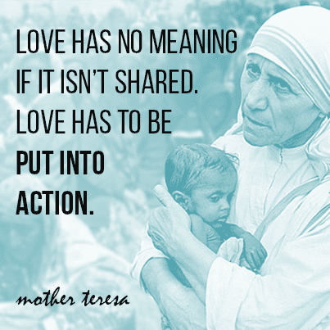

THE LIGHT IS ON FOR YOU
Celebrate the Sacrament of Reconciliation
In the Sacrament of Penance and Reconciliation, also called Confession, we meet the Lord, who wants to grant forgiveness and the grace to live a renewed life in him. In this sacrament, he prepares us to receive him free from serious sin, with a lively faith, earnest hope and sacrificial love in the Eucharist.
Now that COVID restrictions have been sufficiently relaxed, we can resume hearing Confessions in the church's confessional in the rear of the main church.
Confessions will be heard on the fourth Saturday
of every month from 3:30-4:30 p.m. beginning next Saturday, August 27.

FINAL RAFFLE UPDATE
Sadly, there were no winners from St. Paul’s in last weekend’s Multi-Parish Raffle drawing – although there were three $1,000-winners from St. Mary’s in Washingtonville.
Happily, though, your generosity and willingness to take a chance resulted in $12,700 for St. Paul’s. Thank you!

IN THE LOOP
The Hooked & Happy group will meet at 6:30 p.m. this Friday, August 26, in Deacon John Hall. Everyone is invited to an evening of crafting and camaraderie. Bring a project.
A Morning of Prayer with Sr. Peggy Murphy, OP, titled “Art and Spirituality,” has been scheduled for 9:20-11 a.m. Thursday, September 15, at the National Shrine of Our Lady of Mount Carmel. She will discuss Rembrandt’s “Return of the Prodigal Son,” which resonated with him because of his own losses, and the turbulence reflected in Caravaggio’s. “Taking of Christ.” Mass will follow at 11:30 a.m. The cost is $20 per person. Call Carol Bezak, Shrine director, at 845-343-1879.

